**Phase 10: Quality Assurance Testing**

**When Creating new product mentor field (Product Name) without filling.**

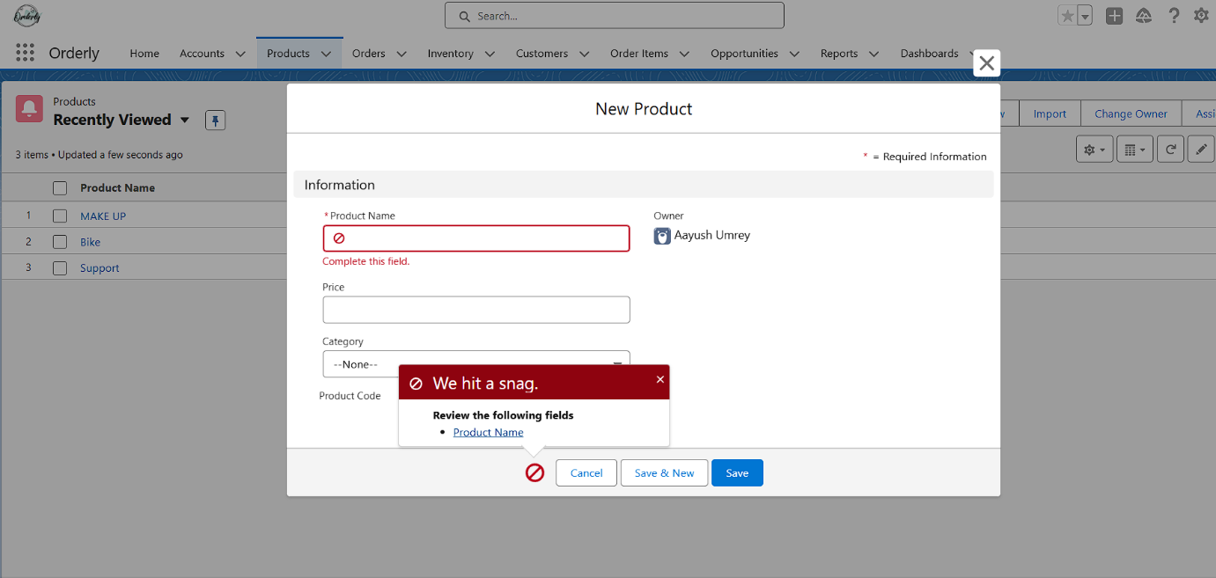

**While creating a new order selecting a record type online, Bulk order, Internal Order**

**Before:**

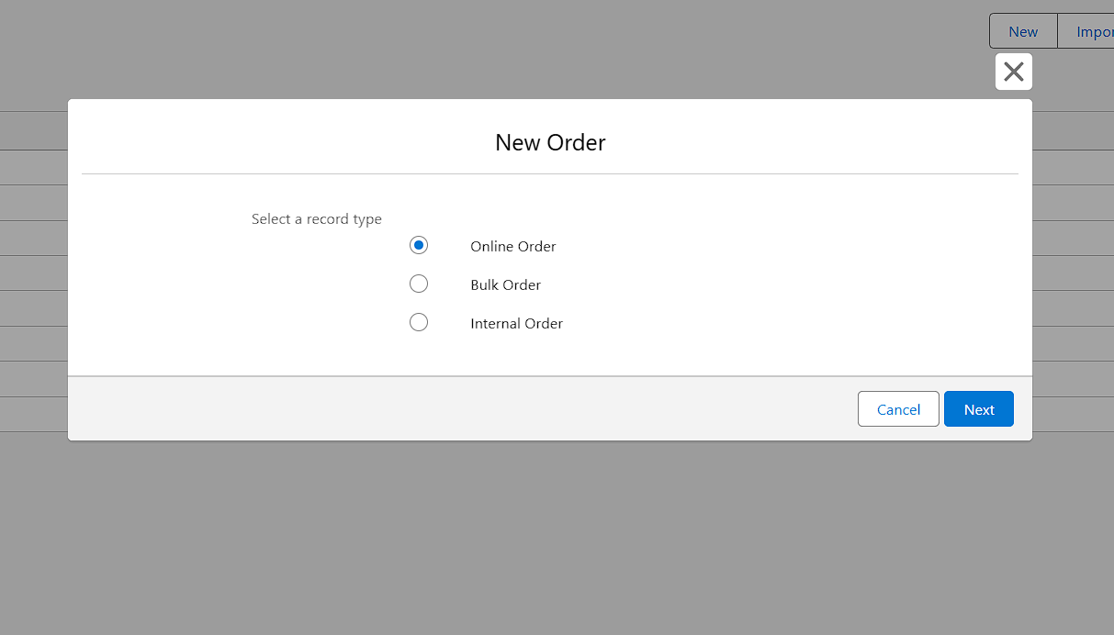

**After: With Order Name(Mandatory Field),customer name mandatory.**

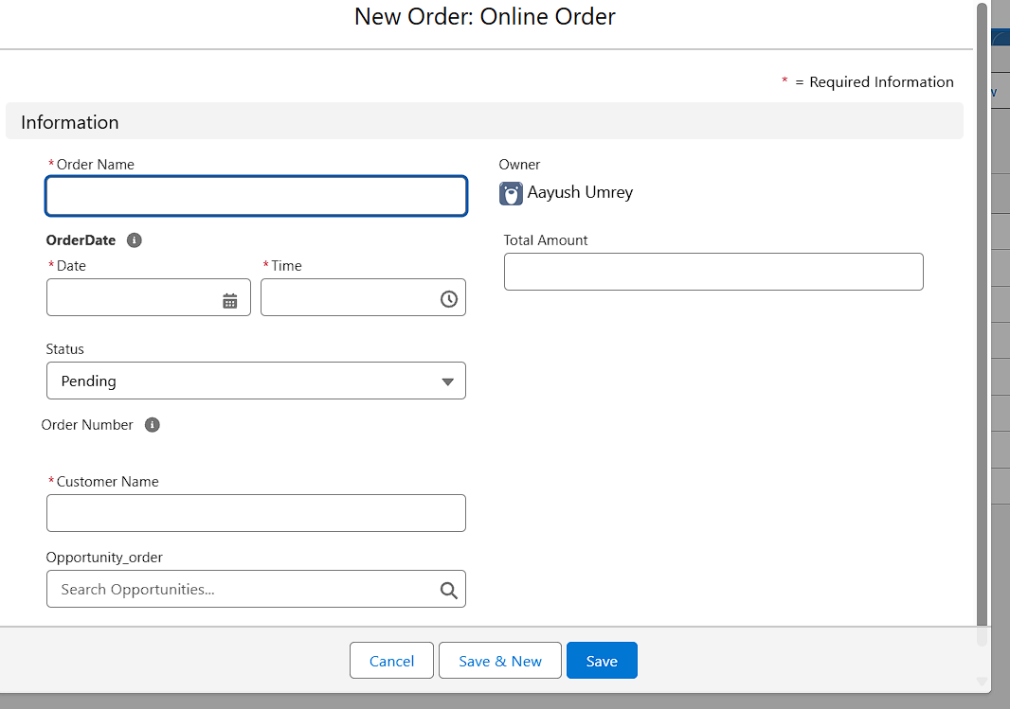

**Automation:**

**The Dashboard will update automatically weekly.**

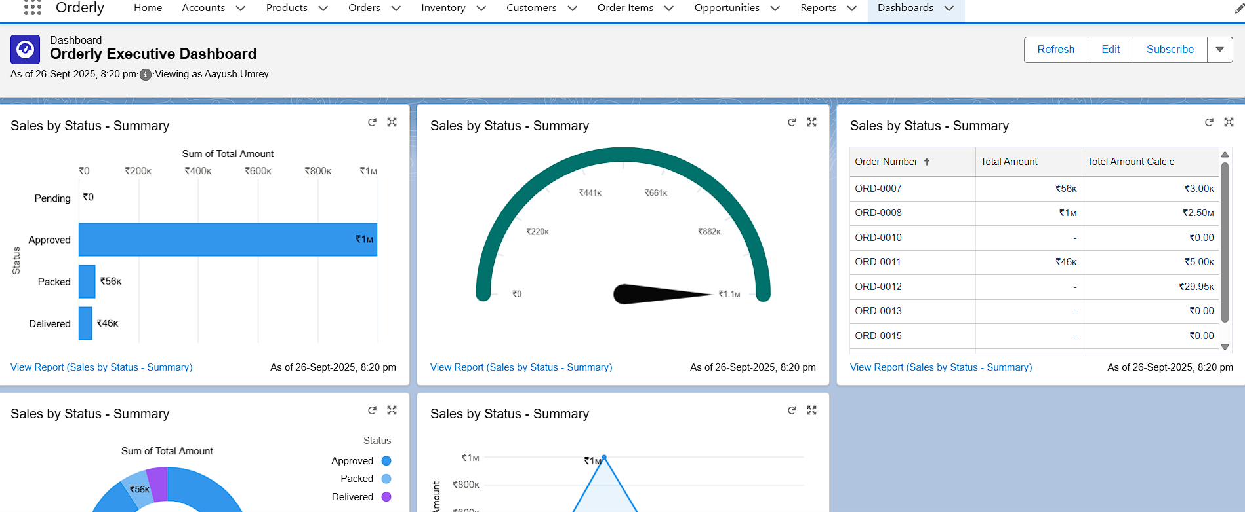

**Process Automation:**

**Whenever we create new opportunity with account and all the detail after saving it automatically saved the account .**

